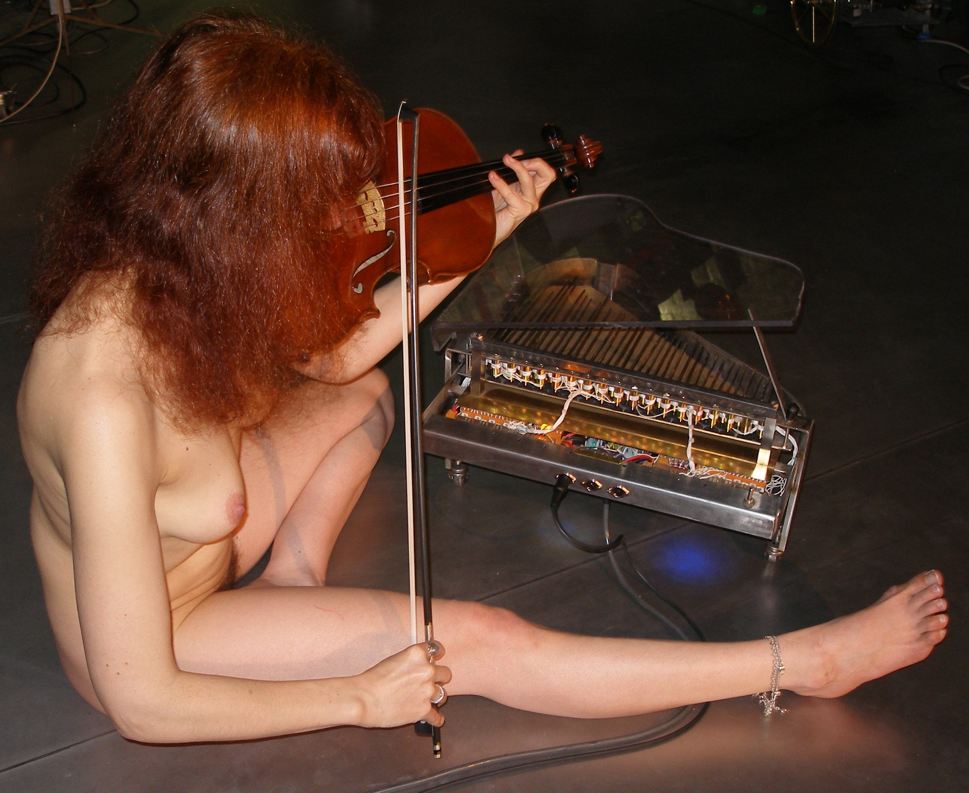

<Toypi>
Definitely, I am not the first designer to build an automated toy piano. My friend and colleage Trimpin has -as far as I know- been the first to deliver a good working programmable acoustic toy piano. Our own design presented here, however started completely from scratch. First we removed and saved the internal harp (clamped rods mounted on a cast iron bar) from a 35 note chromatic toy piano made by Antonelli (Italy). We designed a completely new soundboard, replacing the original plastic construction. The new soundboard was made from hardened brass, the same type as we used before in <aeio>, our robotic cello. In contrast to the robotic cello design however, here we did not clamp the soundboard on its circumference, but we mounted it free swinging, using elastic material for mounting in the piano chassis. This lowers the resonant frequency for the mimimal surface dictated by the design here. The soundboard operates more or less as a Chladni plate. It also contributes greatly to the damping of mechanical noises. To preserve the typical sound, we kept the original design for the small wooden hammers. The keywork was completely replaced by a tubular solenoid assembly, controlled by a couple of PIC microprocessors. The maximum sound volume of the instrument is pretty limited. We could not change this, since sound volume is inherently connected to the sizing of the rod assembly. Louder sound would dictate thicker as well as longer rods. As to the electronic hardware, we used the same printed circuit boards here as developed earlier for <Xy>, our robotic quartertone xylophone. The boards were mounted at the spot where you would normally expect the keyboard. The power supplies found a place under the soundboard. The general shape of the instruments chassis follows closely the typical shape of a normal grand piano, although in this case, it was made entirelly using welded stainles steel. It stand on three sturdy legs. The instrument listens to midi commands and very precise velocity control is implemented.
At first sight, it may appear to be a bit silly to spend all the effort and money to automate such a cheap instrument as the toy piano. The building costs are about a hundreth times the cost of the toy piano itself. But at the other end, there appears to be quite some serious music literature for the toy piano... Margareth Leng Tan even devotes a large part of her career to concerts on this instrument! After all, one must confess its sound is quite unique. Realizing this, it is obvious that the toy piano is quite clumsy to play professionally: not only the keys are undersized for normal hands, but also the mechanics are pretty unreliable. By making a robot player toypiano, it becomes possible to play the toy piano via the interface of a normal touch sensitive keyboard, a hitherto unimaginable possibility. Of course, <Toypi> can also be completely computer controlled and used in interactive applications. As an alternative to MIDI control, we also implemented UDP/IP control.

