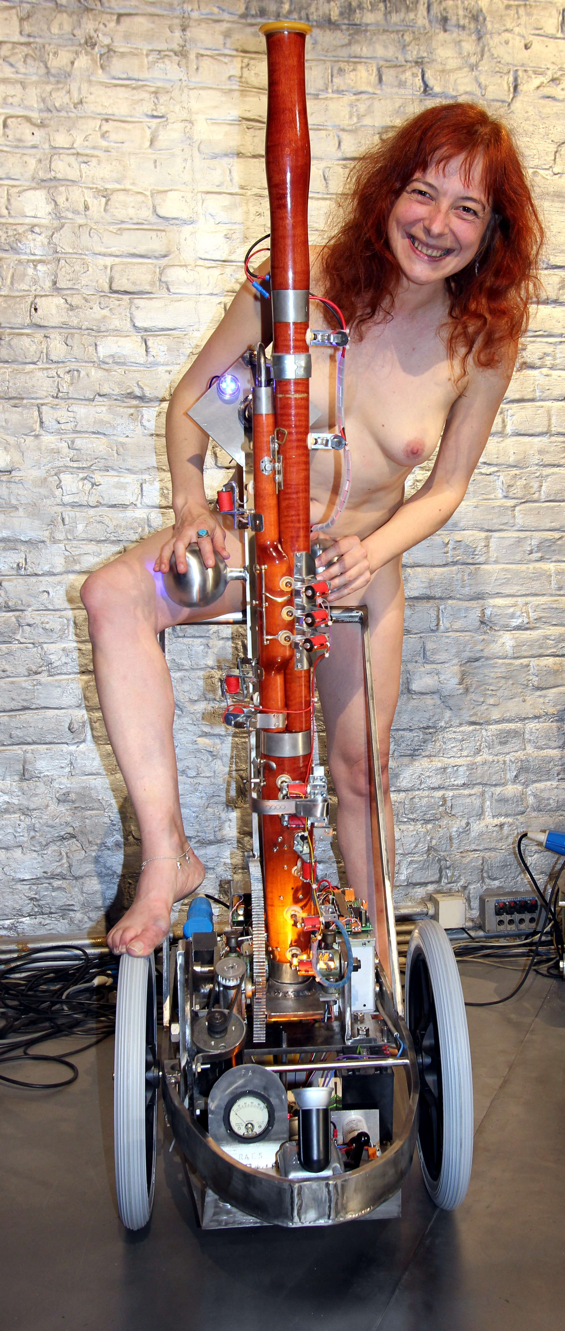
<Fa>
This musical robot is an automated classical music instrument: the bassoon. The reason for taking up this automation project has to do with the simple fact that bassoon players of quality are getting extremely rare. We do like the bassoon sound and thought it would be a most welcomed timbral component in the Logos robot orchestra. The brass section is well represented and covers the bass side pretty well, but as far as woodwinds go, there was a noticable gap. The sound mechanism is based again on an acoustic impedance convertor with a capilary, driven by a motor compressor. The original crook of the bassoon fits very precisely into this part, made on the lathe from massive brass. As mandatory in such an impedance convertor, we first have an anticonical part driven by the motor compressor leading into a capilary traject, after which follows a conical part adapted to the instrument to be driven, in this case the crook of instrument at the end where normally the double reed is mounted. The longer the length of the capilary and the smaller its diameter, the more the sound is determined by the acoustic properties of the instrument alone, but obviously at the same time, sound pressure goes down. Thus we always have to find a compromise.
From an acoustical point of view, the bassoon is a pretty poorly designed instrument. It has a narrow conical bore with no less then 27 holes. A pretty complicated valve and lever mechanism renders it possible for a human player to open and close all these holes with just ten fingers. The resonance characteristics show up a pretty low Q-factor for the fundamental note played and therefore playing exactly in tune is pretty demanding for a human player and asks for a very good lip control. Despite the many valves and mechanics. At the other side of the medal though, this makes is possible, in a robotic design, to implement all kinds of tuning and intonation subtleties even without using complicated fingering combinations.
Although we first considered leaving all mechanics on the instrument intact and replacing the human fingers with action solenoids, some early experiments revealed clearly that this would lead to a lot of unwanted clicking noises. Therefore we decided to get rid of all the mechanics and replace them entirelly with flat pallet solenoid valves working directly on the tone holes. We took a risk here by mounting the valves directly on the instrument, knowing that the mechanical load on the wood would be quite a bit higher than in the traditional instrument. To make sure we would not crack the bassoon and ruin the internal bore, we constructed well fitting saddles from 0.8 mm thick stainless steel plate, for each of the solenoid valves and fixed them lightly with very short plate screws into the wood whereby the real sticking force is realised by glueing the assemblies using a special silicone compound. This job alone took almost a month of work, in part also because the silicone compound takes about 24 hours to cure.
An important aspect of the firmware for the ARM processor used here, is that we had to implement a formant around 500Hz in the driving source signal. This conforming to the findings published by F.Fransson in 1966, where he proves clearly that this formant cannot be attributed to the bassoon as a resonator but solely to the action of the double reed. The formant filter implemented affects the lower partials. Note that notes higher than midi 60, do not have this formant, note 71 being at the center of the formant frequency itself.
Since some movement of the bassoon is quite normal in human performance, we wanted to implement that as well. Hence we suspended the entire bassoon and motor drive assembly on a spindle such that it is allowed to rotate over an angle of about 30 degrees.
A novel aspect of the design of this robot is the implementation of a fingered vibrato, conforming to the tradition in vibrato playing up to the second half of the 19th century.

