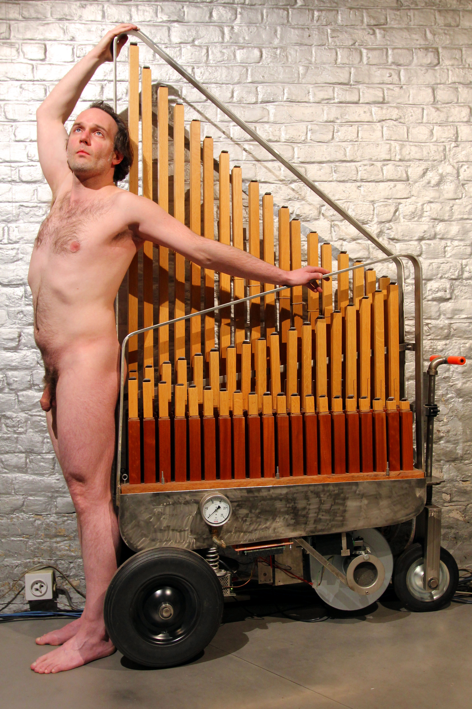
<Krum>

The design of this musical robot started with an offer found on the August Laukhuff website for a Krummhorn 8-feet register made with full length wooden resonators and shallots. Oak and mahagony wood is used for the resonators. The resonators have regulating flaps. As for the Krummhorns with metal resonators, the resonators with narrow scales in the bass must be shortened, while those with large scales can be built in full length. Narrow tapered and cylindrical shallots are suited. Since we desired wooden shallots, the blocks and boots are also made of wood. The sound was designed such as to be soft and reedy, very rich in overtones. It promised to become a viable alternative for our <Vox Humanola> at the one side, and an excellent gradation of the latters sound in the orchestral spectrum of the complete <M&M> orchestra.
In the <Krum> robot we designed around this register, the notes are switched inside the windchest with electrical pallets, solenoid driven. Wind pressure control is possible, although as can be expected from single reed pipes, does not preserve tuning! Maximum wind pressure is 85mm watercolumn and generated by a 130Watt Laukhuff Ventus-type organ blower driven by a programmable 3-phase motor controller from Siemens. Air production is 3 cubic meters a minute. Normal working pressure should be 75mm watercolumn. A manometer is mounted on the windchest such that monitoring of pressure is easy.
The entire circuitry for this robot makes use five fast PIC controllers: Microchip PIC18F2520 - I/SP types. For each group of 16 notes, a controller takes care of the midi input parsing and the note on/offs, mosfets and pallet valve solenoids. A fifth PIC microcontroller takes care of the steering of the windvalve as well as of the motor commands and the PWM for the 3-phase motor controller.
Mapping:



