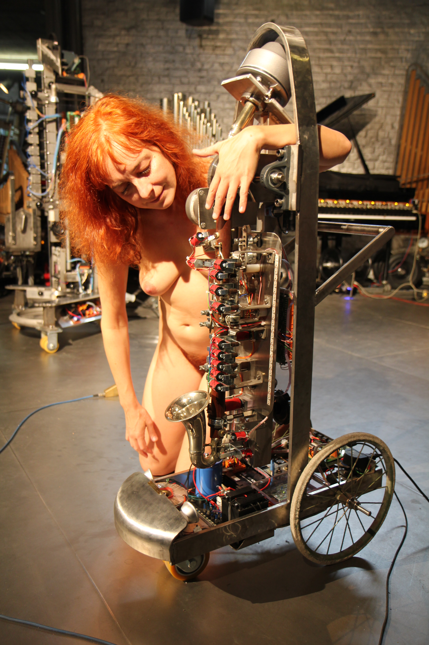
<Klar>
A somewhat rare instrument became the starting point of this robot: an alto clarinet built by Higham in Manchester in the first half of the 20th century. It's an Eb instrument, a fifth lower than the regular Bb clarinet and thus reaching down to G (midi 43) in absolute pitch. In any case it's an instrument that never found its way into the regular symphony orchestra. It has a curved metal bell and is made of coconut wood. The mouthpiece connects to the instrument through a bent neck.
For the design we benefited from the experiences gained with previous wind instruments such as <Korn>, <Autosax> and <Fa>. Our prime concern was to make the mechanical parts as quiet as possible. <Ob> and <Fa> in that respect were the most succesful so far, but in a clarinet the forces needed to open and close the valves are quite a bit higher than on the oboe. On the other hand the solution that has made <Fa>, the bassoon, a success cannot be applied here: in <Fa> we removed all existing valves and replaced them with solenoid driven pallet valves directly mounted on the bassoon. The clarinet body however just does not offer enough space to make that a viable solution. Thus we had to find something in between what we realized for <Ob> and <Fa>. Some original valves were removed and replaced by solenoid driven valves mounted on a separate chassis. For other valves we left the original valves and springs in place, but operated them with felt or rubber padded solenoids replacing the human fingers.
The sound driver follows a recipe that has proven its validity over many previous wind instrument robots: the membrane compression driver followed by a capillary impedance convertor. Obviously the impedance convertor we finally inserted has quite different proportions than the ones used for the brass and double reed instruments. One of the problems was to work out empirically the equivalent acoustical length of the clarinet mouthpiece. There are -so far as we could find out- no mathematical models available. It is known in acoustics that a single reed can be considered to be a flat bar clamped at one end, but if we look at the spectrum produced once the reed is mounted on the mouthpiece and coupled to the resonator, almost nothing of this theory seems to hold true. What we do know is that the pitches that can be produced on the clarinet, must be below the natural frequency of the reed. Thus the reed is the limiting factor for the ambitus of the instrument. As we do not have this limit in our design, we can extend the ambitus of the clarinet way beyond what is possible on a normal instrument with a reed. It is not by accident that the clarinet came to join the robot orchestra much later than all the previously realised robotic instruments. In many respects, the clarinet poses many more implementation problems than brass or double reed instruments, for its expressive possibilities are the widest of all wind instruments. First of all, there is the extreme dynamic range: close to 110dB, well above what is reachable with 16 bit processors. Furthermore, through reed control, the timbre of the sound is modulated continuously. This called for a pretty complex compression driver with many parameters, leading to a wealth of controllers for the user. Then of course, there are the 'special' playing techniques such as vibrato, flatterzunge as well as quartertones and microtonal inflections. Because of these complexities, we called in a true 32-bit ARM processor.
As in some previous robotic wind instruments, here again we implemented some form of movement: the clarinet together with the valve chassis are suspended in a cradle and can perform pendulum-like movement. Seen in the group of monophonic wind instruments designed and build sofar, <Klar> is doubtless the most flexible instrument. The wealth of controllers make it possible to program the instrument such as to sound sounds completely unlike what we expect clarinets to be capable of doing. It can easily surpass the possibilities of human players but at the other hand, human players can produce sounds that this robot is not yet capable of producing, such as some multiphonics, loud slaptongues and vocal-instrumental interfering sounds.

