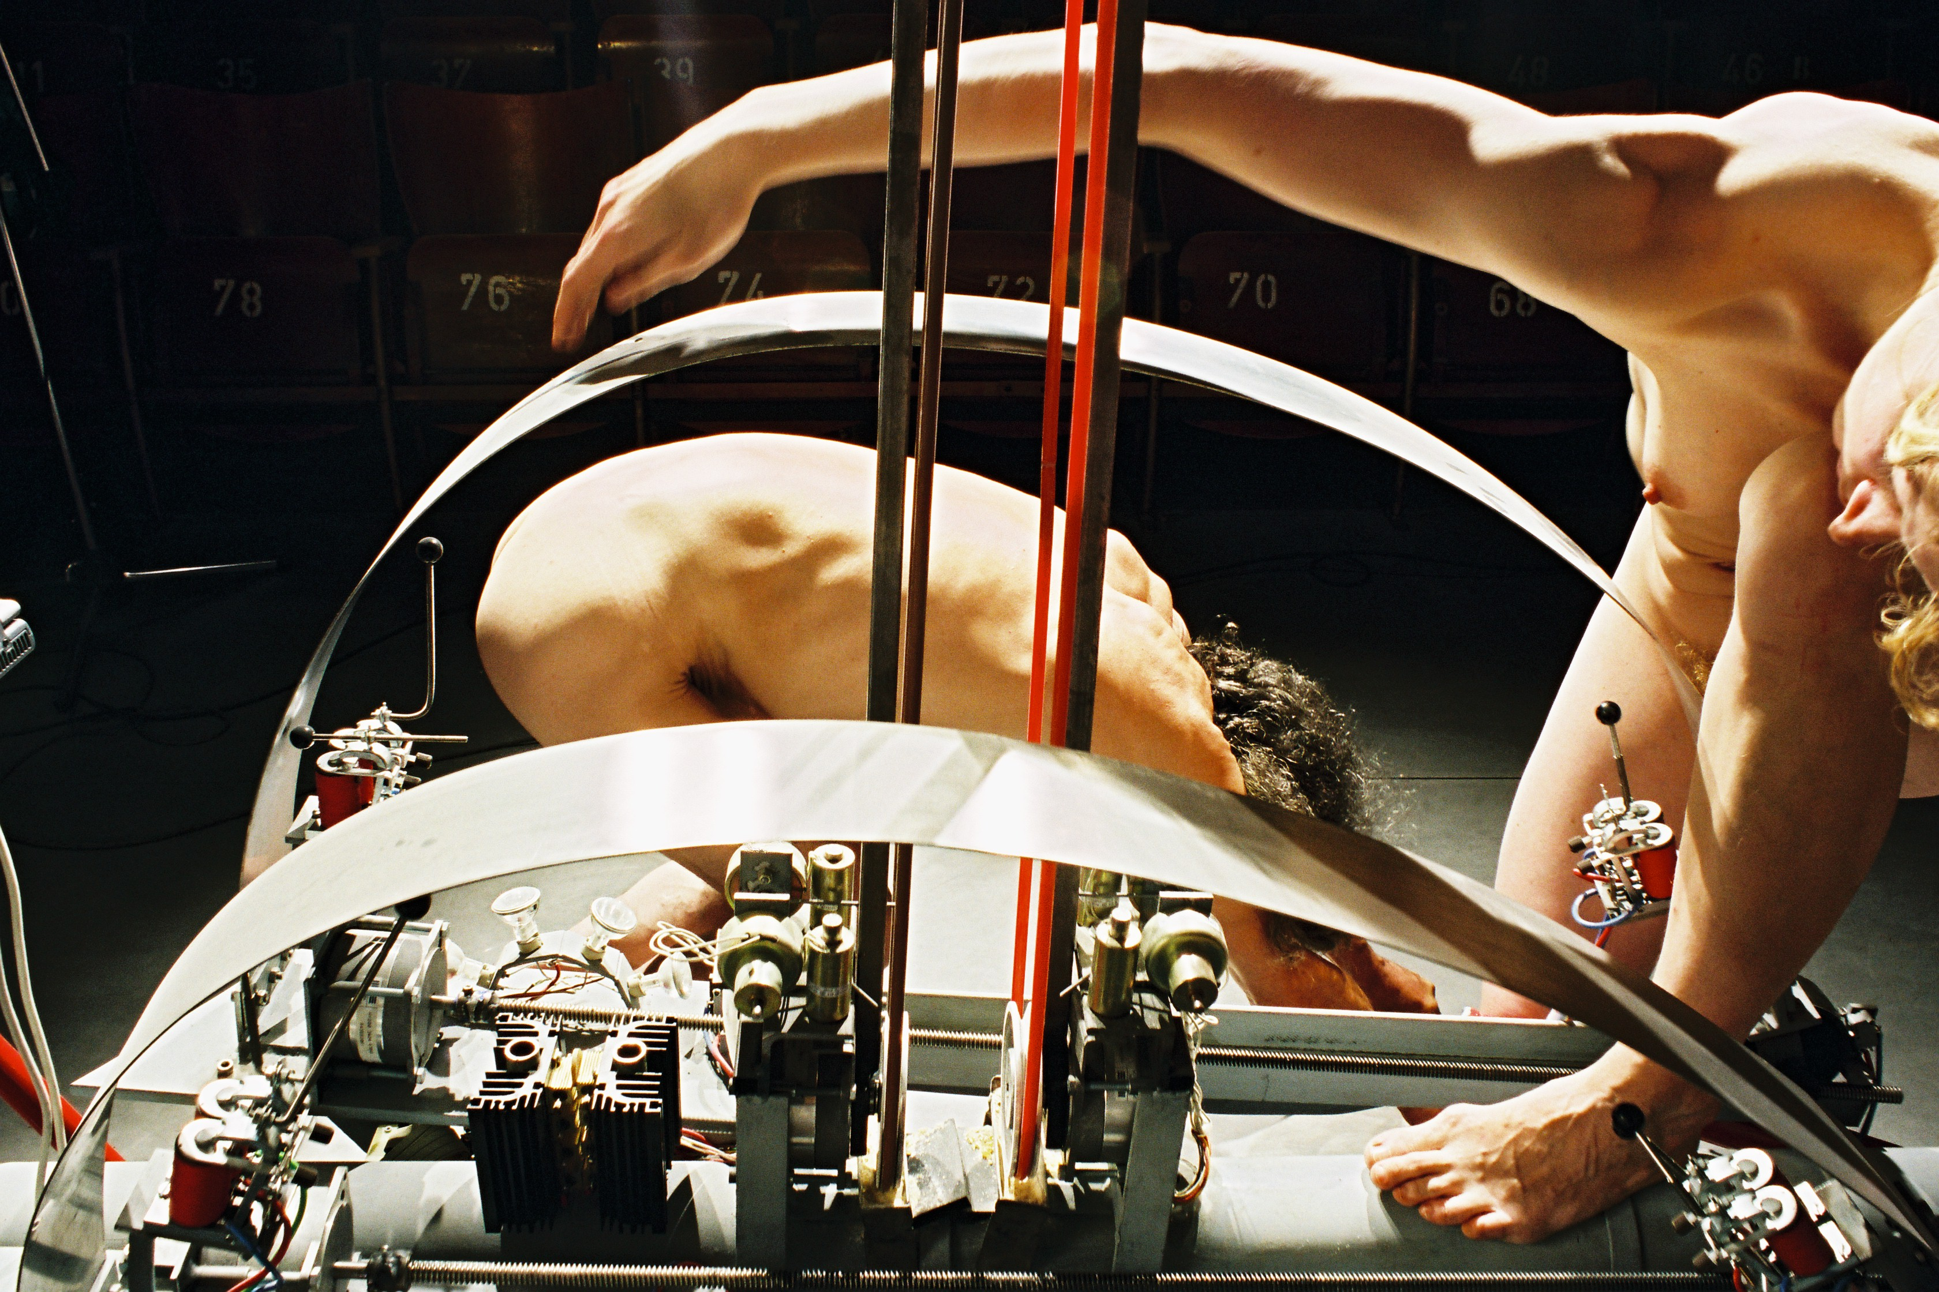

<Flex>
This musical robot consists of an assembly of singing saw or flexatone like soundsources: blades of hardened stainless steel struck by solenoid driven beaters and bend by a system of heavy duty stepping motors. In this respect it may be considered a realization of Russolo's fifth category in noise makers (intonarumori): sound of metals, stone etc.
The individual beaters for the steel blades are driven by strong solenoids. Musical dynamics are implemented by applying pulse width modulation techniques in the driver circuits. However, the dynamic range is different from blade to blade and also depends on the amount of bending applied by the stepping motors. The circuitry used is very similar to that developed for our <Vibi> and <Rotomoton> automats, although we used a different kind of stepping motor (4-phase, 0.45 Ohm coil resistance, 1.2mH inductance), requiring a much higher current of up to 4.5A per winding. Two PIC microcontrollers are used for the blade steppers.
The stainless steel blades can also be bowed by two individually steerable bowing motors and two attack solenoids. Here again we decided to use stepping motors to drive a round nylon belt with rosin over two aluminium wheels 100mm in diameter. Since motor speed can be controlled by the software in the range of 0.5 Hz to 5 Hz, the bowing speed ranges from 160cm/s to 1.57m/s. The bow assembly is pressed against the blades by the action of a couple of Lucas-Ledex solenoids. The solenoids used are: Ledex STA series push tubular solenoid type nr. 195207-228. They have a cold DC resistance of 19.1 Ohm. The nominal working voltage, at which the coils can be activated indefinitly long is 13.8V. At 10% duty cycle, a voltage of 44V may be applied. The release of the bow follows under gentle springload. Positioning of the bows against the blades is achieved with four softshift solenoids, PWM-controlled by four PIC controllers. The bows, 70cm in length, are mounted vertically, facing each other on the central tube of the robot.
To prevent the all-notes-on on startup bug in the very first versions of earlier automats, this instruments should receive a pincode (241) before the motor and solenoid power supply is switched on. The software does program the microcontrollers and timer chips on board, prior to switching on the high power supply. In total, this automat is equiped with 8 PIC microcontrollers: 4 for each of the stepping motors, 4 for each of the bow movement softshift solenoids.
The instrument is mounted in a TIG-welded triangular structure with three large and sturdy wheels, 40 cm in diameter each.

